 

**KENDRIYA VIDYALAYA KHANAPARA**

**CBSE AISSCE (2022-23)  
COMPUTER SCIENCE**

**PROJECT REPORT**

**ON**

**“Virtual Assistant (RIMA)’’**

**PROJECT REPORT PREPARED BY:**

**STUDENT NAME - Kunal Saha**

Class **- XII ‘A’**

CBSE Roll No - 26

Kendriya Vidyalaya Khanapara Guwahati

**TABLE OF CONTENTS**

| **S. No.** | **Title** |  |
| --- | --- | --- |
| 1 | Acknowledgement |  |
| 2 | Certificate by Guide |  |
| 3 | Certificate by Examiner |  |
| 4 | Introduction to Project |  |
| 5 | Details of Project |  |
| 6 | Applications of Project |  |
| 7 | Code ( Python Program) |  |
| 8 | Output Screenshots |  |
| 9 | Bibliography |  |

**ACKNOWLEDGEMENT**

I, **Kunal Saha** of class XII-A, hereby thank my Computer Science teacher **Shri Gurnishan Singh** for his valuable guidance and support. I also thank my Principal **Shri Sanjay Kumar** for continuous academic support. I would also like to thank my family and friends for encouraging and supporting me during the course of this project. Finally I would like to thank CBSE for giving me this opportunity to undertake this project.

**Signature**

**CERTIFICATE BY GUIDE**

This is to certify that **Kunal Saha** of class **XII ‘A’** has completed the project independently under my guidance and prepared the report entitled “**Virtual Assistant (RIMA)**”. The report is the result of his consistent efforts and endeavors. The report is found worthy of acceptance as final project for the subject **Computer Science (083)** of CBSE AISSCE 2022-23.

**Mr. Gurnishan Singh** **PRINCIPAL**

PGT Computer Science

KV Khanapara Guwahati

**CERTIFICATE BY CBSE EXAMINER**

The project report entitled “ **Virtual Assistant (RIMA)** ’’, Submitted by **Kunal Saha** of class **XII ‘A’** the subject **Computer Science (083)** of CBSE AISSCE 2022-23 at Kendriya Vidyalaya Khanapara, Guwahati has been checked and examined.

Internal Examiner External Examiner

**INTRODUCTION TO PROJECT**

The project is on virtual assistant. A virtual assistant is an intelligent application that can perform tasks or provide services for a person responding to orders or inquiries.

**Details of Project**Some VAs can understand and respond to human speech using synthesized voices. Users may use voice commands to request their VA to answer the questions, manage home appliances, control media playing, and handle other essential activities like email, creating the actions lists, and organize the meetings on calendars.

Module used:

1. pyttsx3: it is a text-to-speech conversion library in Python.

2. speech_recognition: is a compact easy-control speaking recognition board. It is a speaker-dependent module.

3. datetime: this module supplies classes to work with date and time. These classes provide a number of functions to deal with dates, times and time intervals.

4. wikipedia: is a Python library that makes it easy to access and parse data from Wikipedia.

5. os: provides functions for creating and removing a directory (folder), fetching its contents, changing and identifying the current directory, etc.

**Applications of Project**

1. First, Rima will greet you as,” Good Morning/Evening/Afternoon Hi Kunal!!, myself Rima, how can I help you?”

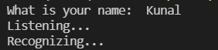

1. **wikipedia**



1. **Opening google**

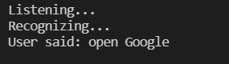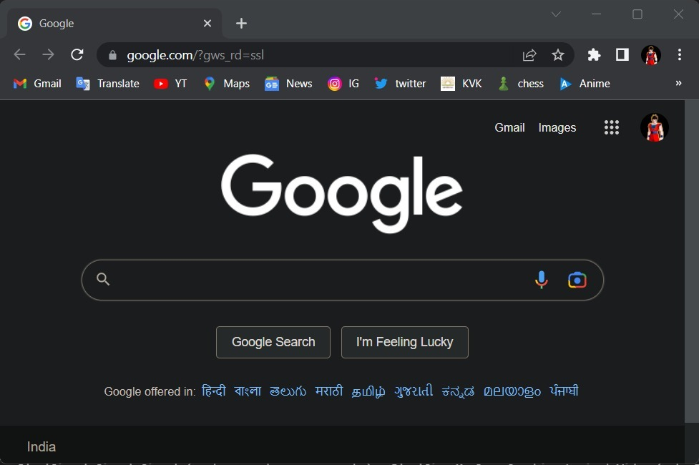

1. **Play Song**

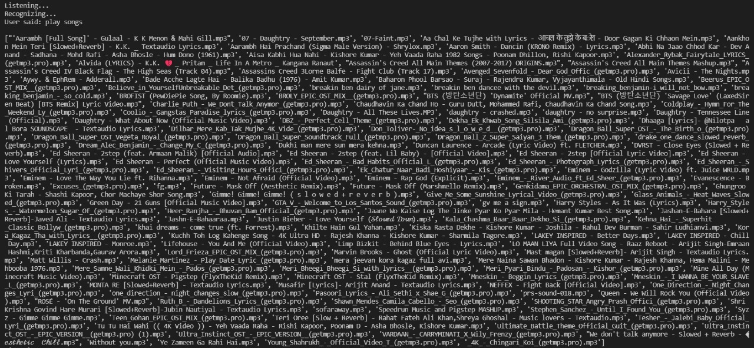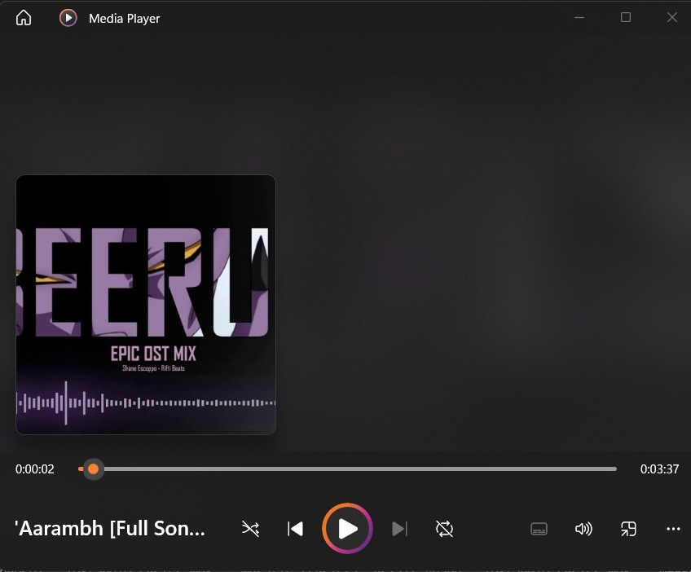

1. **Rima will tell time in H:M:S format**



1. **Opening WhatsApp**

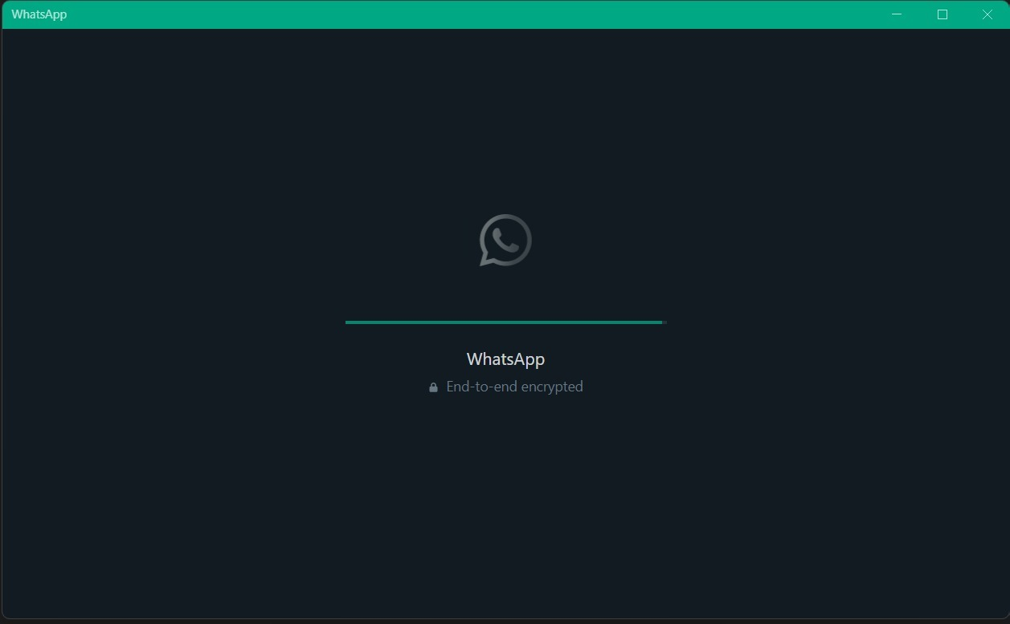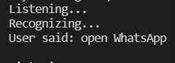

**CODE**

**import pyttsx3**

**import speech_recognition as sr**

**import datetime**

**import wikipedia**

**import webbrowser**

**import os**

**def rima():**

**user = input("What is your name: ")**

**engine = pyttsx3.init('sapi5')**

**voices = engine.getProperty('voices')**

**# print(voices[1].id)**

**engine.setProperty('voice', voices[1].id)**

**def speak(audio):**

**engine.say(audio)**

**engine.runAndWait()**

**def wishMe():**

**hour = int(datetime.datetime.now().hour)**

**if hour>=0 and hour<12:**

**speak("Good Morning!")**

**elif hour>=12 and hour<18:**

**speak("Good Afternoon!")**

**else:**

**speak("Good Evening!")**

**speak(f"Hi {user}!!, myself Rima, how can I help you?")**

**def takeCommand():**

**#It takes microphone input from the user and returns string output**

**r = sr.Recognizer()**

**with sr.Microphone() as source:**

**print("Listening...")**

**r.pause_threshold = 1**

**audio = r.listen(source)**

**try:**

**print("Recognizing...")**

**query = r.recognize_google(audio, language='en-in')**

**print(f"User said: {query}\n")**

**except Exception as e:**

**# print(e)**

**print("Say that again please...")**

**return "None"**

**return query**

**if __name__ == "__main__":**

**wishMe()**

**while True:**

**query = takeCommand().lower()**

**#logic for executing task based on query**

**if 'wikipedia' in query:**

**speak('Searching Wikipedia...')**

**query = query.replace("wikipedia", "")**

**results = wikipedia.summary(query, sentences = 2)**

**speak("According to wikipedia")**

**print(results)**

**speak(results)**

**elif 'open youtube' in query:**

**webbrowser.open("www.youtube.com")**

**speak("opening YouTube")**

**elif 'open google' in query:**

**webbrowser.open("www.google.com")**

**speak("opening Google")**

**elif 'open physics wala' in query:**

**webbrowser.open("www.pw.live")**

**speak("opening Physics Wallah")**

**elif 'open instagram' in query:**

**webbrowser.open("www.instagram.com")**

**speak("opening Instagram")**

**elif 'play songs' in query:**

**speak("playing songs")**

**music_dir1 = 'D:\\songs\\Spotify'**

**songs1 = os.listdir(music_dir1)**

**print(songs1)**

**os.startfile(os.path.join(music_dir1, songs1[0]))**

**elif 'the time' in query:**

**strTime = datetime.datetime.now().strftime("%H:%M:%S")**

**speak(f"the time is {strTime}")**

**elif 'open whatsapp' in query:**

**speak("opening WhatsApp")**

**wapp_file = "C:\\Users\\kunal\\AppData\\Local\\WhatsApp\\WhatsApp.exe"**

**os.startfile(wapp_file)**

**elif 'tell me a joke' in query:**

**print()**

**speak("Utkarsh is a good boy")**

**print("Utkarsh is a good boy")**

**rima()**

**Bibliography**

YouTube(channel name)- code with harry

Stack Overflow - https://stackoverflow.com

[**www.cbseportal.com**](http://www.cbseportal.com)

[**www.cbseportal.com**](http://www.cbseportal.com)

[**www.cbseportal.com**](http://www.cbseportal.com)

[**www.cbseportal.com**](http://www.cbseportal.com)

[**www.cbseportal.com**](http://www.cbseportal.com)

[**www.cbseportal.com**](http://www.cbseportal.com)

[**www.cbseportal.com**](http://www.cbseportal.com)

[**www.cbseportal.com**](http://www.cbseportal.com)

[**www.cbseportal.com**](http://www.cbseportal.com)

[**www.cbseportal.com**](http://www.cbseportal.com)

[**www.cbseportal.com**](http://www.cbseportal.com)

[**www.cbseportal.com**](http://www.cbseportal.com)

[**www.cbseportal.com**](http://www.cbseportal.com)

[**www.cbseportal.com**](http://www.cbseportal.com)

[**www.cbseportal.com**](http://www.cbseportal.com)

[**www.cbseportal.com**](http://www.cbseportal.com)